SPORTS IN ANTIQUITY

Museu d'Arqueologia de Catalunya

By Pasko Varnica
The vibrant city of Barcelona has many tourist attractions. Museum of Archaeology of Catalonia may not be high on everyone’s list of places to visit, but if you spend a few days in Barcelona and are interested in Roman history, the museum is worth a look. Housed in a beautiful palace built for the 1929 World Exhibition, the museum is located next to the Sants-Montjuic Park. Of all the pieces in its possession, “The Three Graces”, a mosaic that has inspired countless artists through the ages, impressed me the most. That said the reason for my visit was the museum’s famous mosaic depicting a chariot race, known to the locals as Circus Mosaic.

Circus Mosaic
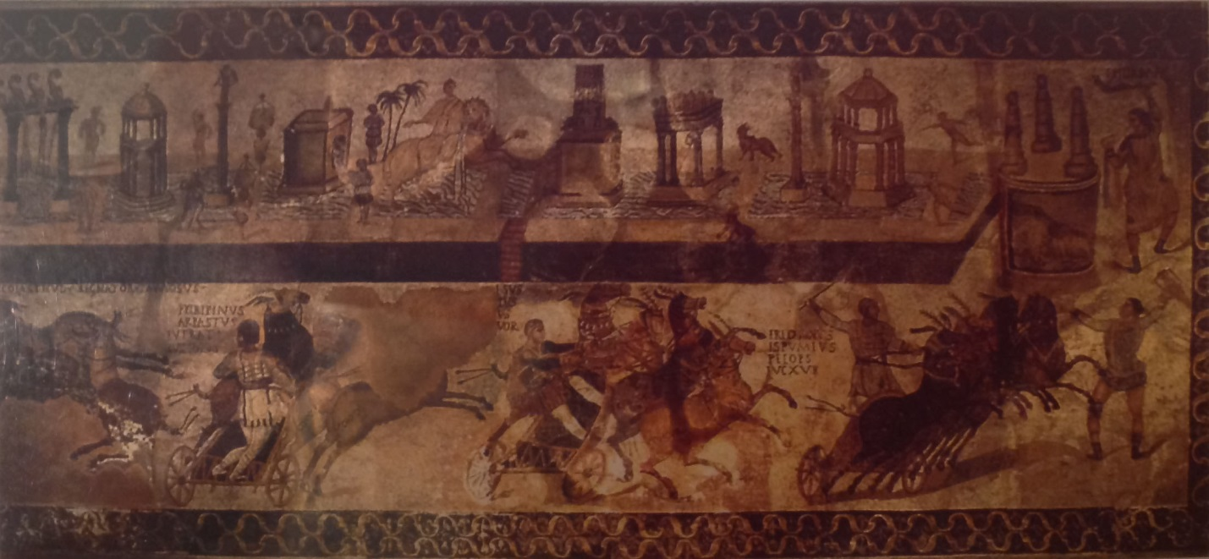
Picture of how the mosaic might have looked originally.

The above is the best conjecture about the missing pieces of the mosaic. Shame that the picture, as it appears in the museum next to the real thing, is dark without the bright colors of the original. It is nevertheless an excellent effort, showing how the entire mosaic might have looked other than a small portion in the lower half that was impossible to recreate. This unrestored area most likely represents the four horses of the White faction charioteer, with names of the horses immediately above them.
The real mosaic is quite large, see below the picture taken from its right side. The bench, inserted in the picture for perspective purposes, illustrates its size.
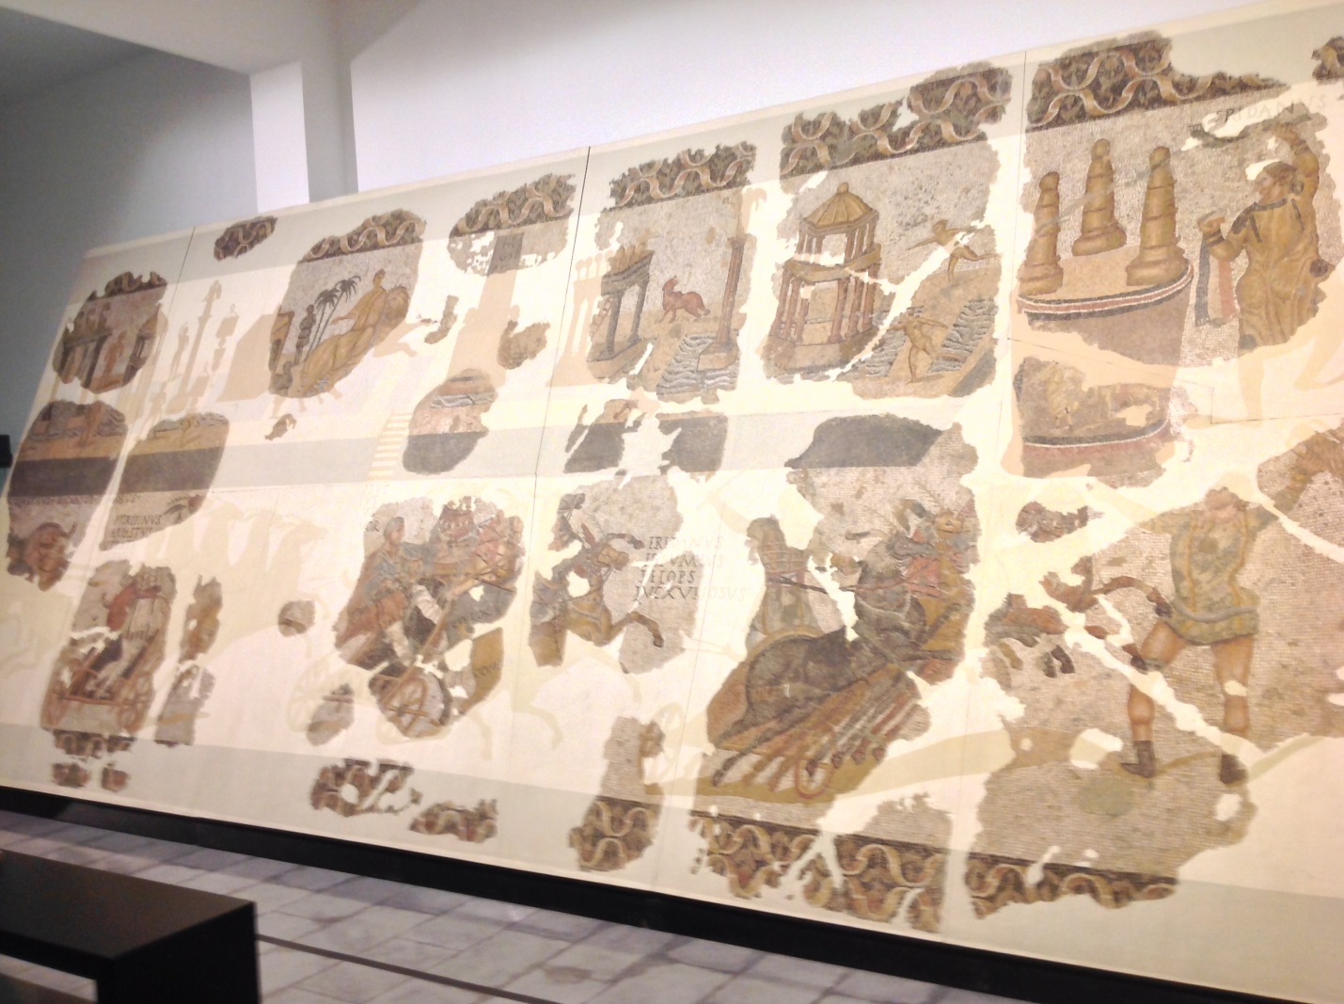

Next, depicted below, is the view from the left side, followed by a detail of the best-preserved area. Notice that the mosaic has an elaborate border framing its top, bottom and right, but not the left side. Was the left side next to the entrance door?
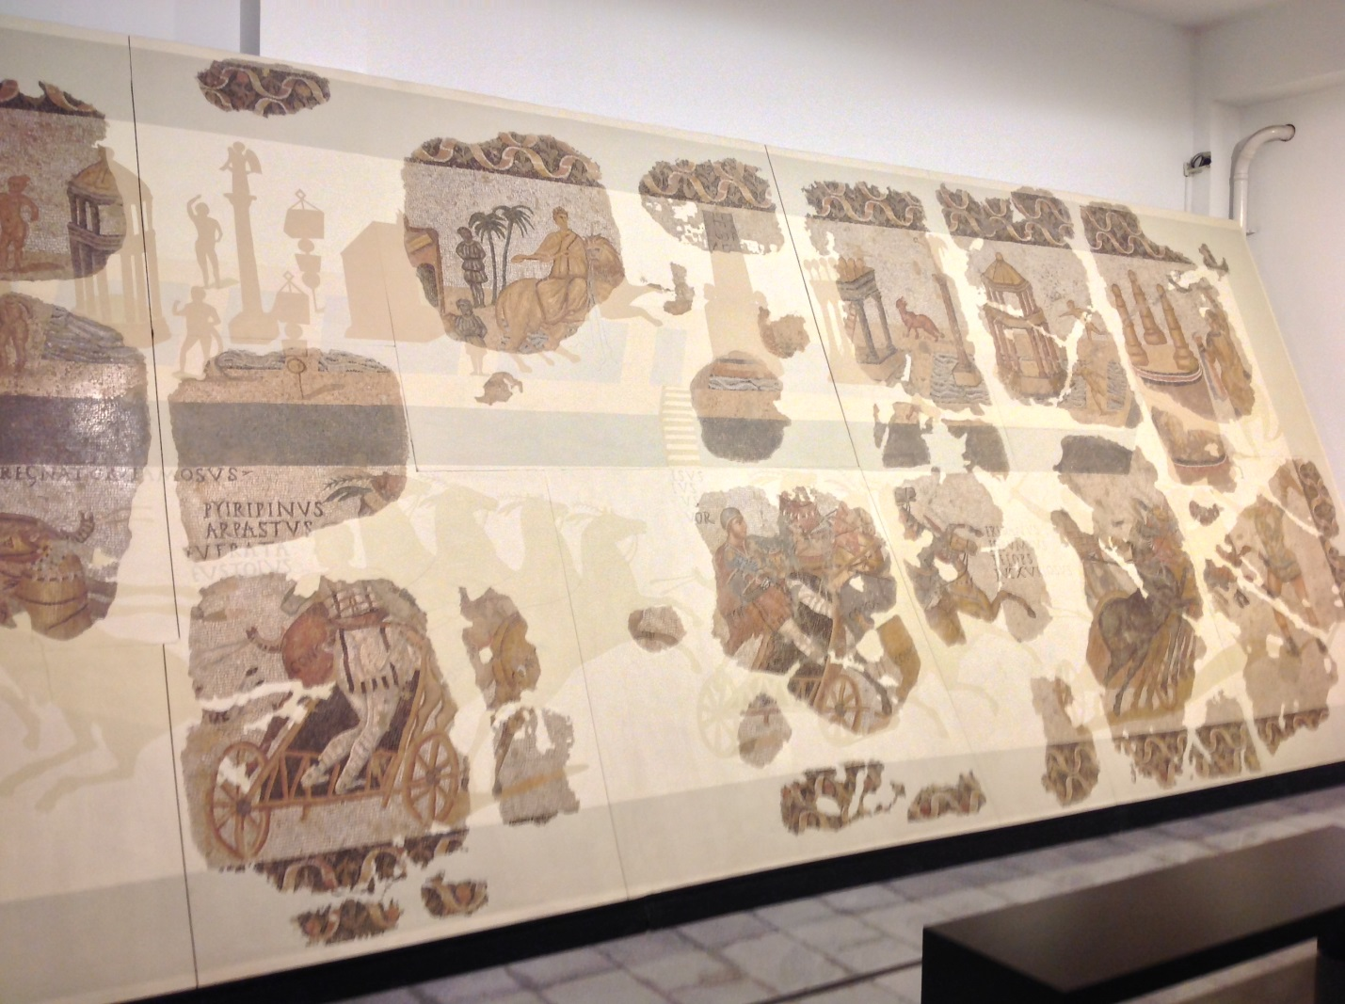
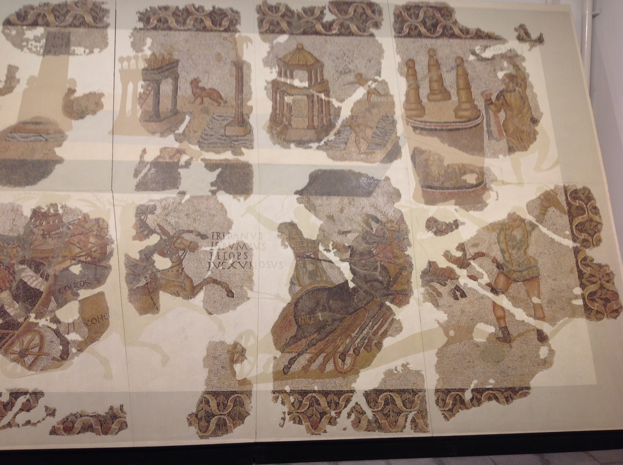
Circus Model
Unexpected for me was to find in the museum a magnificent model of a circus arena. The model is approximately two and a half feet wide and close to six feet long. This is where pictures are better than words. The first image, see below, is the view from the carceres end. The small magistrate stand along the finish line is visible on the left side. The euripus is noticeably off-axis as it was in real life in every circus. The elaborate bas-relief on the bottom of the stands is exquisitely reproduced.
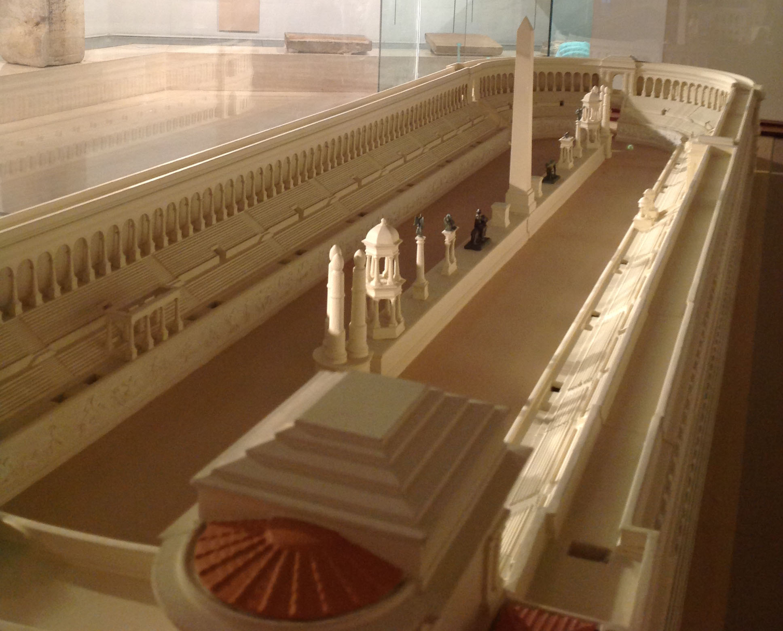

Carceres and the two flanking towers followed by the view of the carceres from inside the racing arena are below. In the first picture, observe that the Egyptian obelisk is in the front of the pulvinar (emperor’s lodge). Is the location near the emperor’s lodge of any significance or was the obelisk placed on the euripus randomly?
Missing from the model are the racing lines drawn on the ground of the circus. The white starting line traced from side to side should be about half way between the metae and the carceres (see the second picture). The finish or winning line, as it was known went from the metae to the stands at the end of the left return lap in the front of the magistrate stand. The lines marking the lanes each chariot maintained prior to reaching the starting line were drawn from each carcere to the starting line.

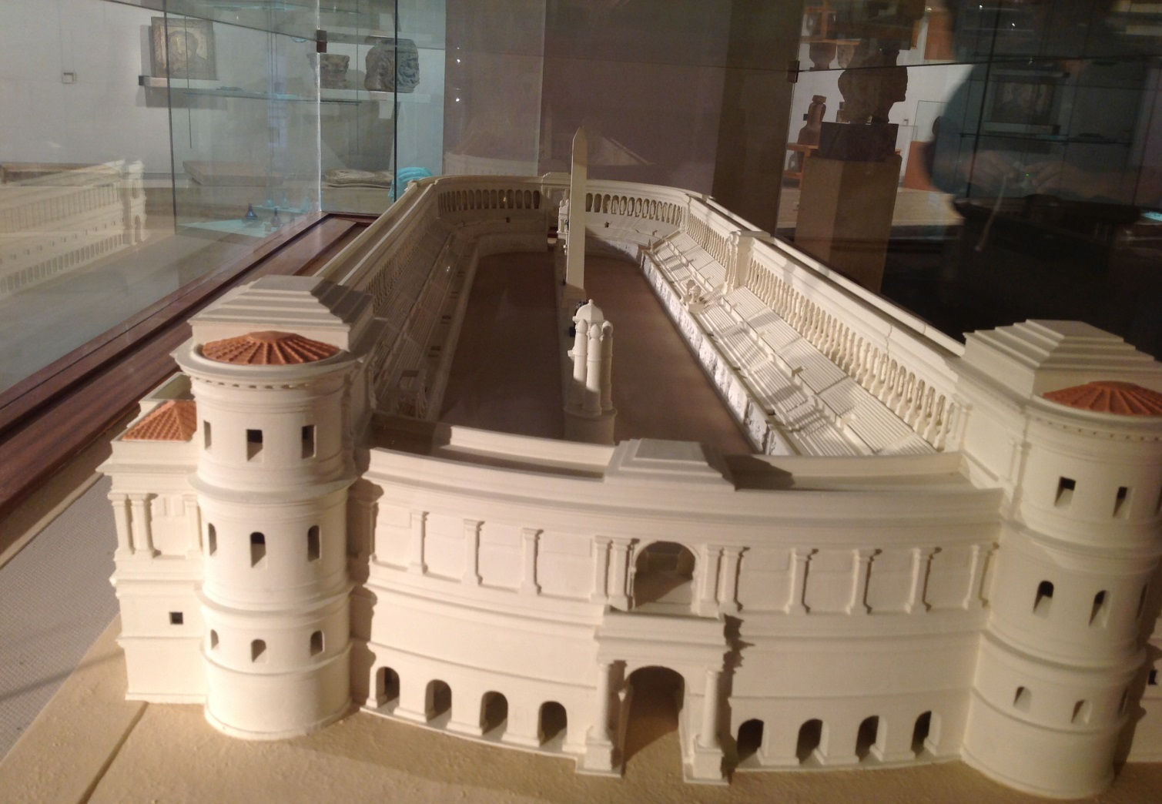

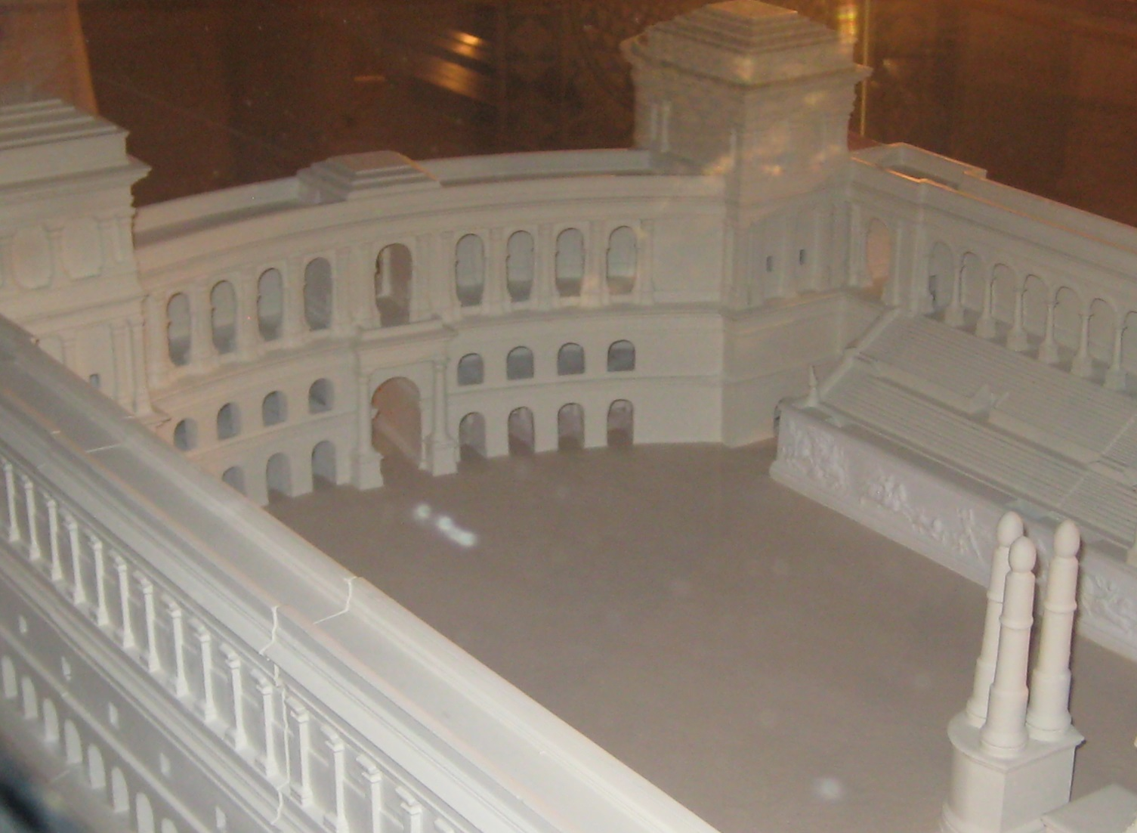

Last picture was taken from the left side of the carceres. In it, the euripus appears to be straight, running in the middle of the racetrack. We know from the top picture that euripus was off-axis. Observe that the camera was not situated above the central tower of the carceres. Had the camera been positioned in the middle facing straight at the triumphal gate on the opposite end of the circus, the off-axis line of the euripus would be obvious. This is the perspective that the charioteers had from the carceres prior to the start (granted, their perspectives would be from the ground, not from up in the air where the camera stood).
Was there a starting cage that had an advantage over other cages? Was it better to be next to the edge of the euripus and take quick turns instead of wide and consequently long and time-consuming ones of the right-most position? Was leaving from the left-most carceres the most beneficial? We do not race chariots but we drive cars. We know that the left-most charioteer would have to slow down to make the left turn once he reached the metae, while the right most one would continue at full speed. Those chariots in the middle positions were squeezed from both sides.

Did the cage number a chariot sprang from influence the betting in any way? Was the right to left order announced prior to the start of a race? Did knowing in advance the cage number give an edge to the gambler? Possibly, knowing how gamblers reason, but I doubt it. I think that any advantage at the start of the race was solely dependent on the skill of an individual driver and the ability of his racehorses.
Roma architects designed circus arenas with the utmost care to ensure a fair start of the race and to offer an unparalleled visual pleasure to the spectators. I wish I were there just for one race.

