SPORTS IN ANTIQUITY

Il Civico Archeologico Museo di Milano

By Pasko Varnica
8/14/2014

The following is an excerpt from ORDO URBIUM NOBILIUM (THE ORDER OF FAMOUS CITIES), written by Ausonius around 388 or 389 CE, The Loeb Classical Library, English translation by Hugh G. Evelyn White

“At Milan also are all things wonderful, abundant wealth, countless stately houses, men able, eloquent and cheerfully disposed; besides, there is the grandeur of the site enlarged by a double wall, the Circus, her people's joy, ………”

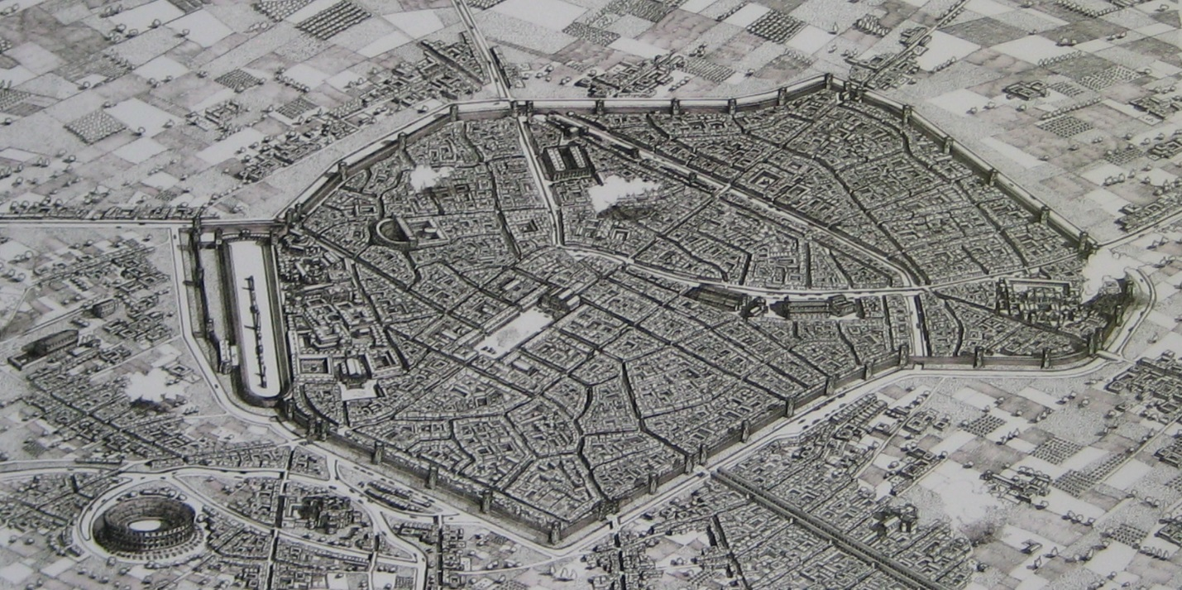

Drawing of Mediolanum, as it may have looked in the IV century, Il Civico Archeologico Museo of Milano

Should you visit Milan in northern Italy, do not miss the newly renovated church of San Maurizio. The google map (see link below) shows the church location and has several pictures of the stunningly beautiful interior renovation.
https://plus.google.com/113496752283263226681/photos?hl=en

The church originally belonged to the female Benedictines convent of Monastero Maggiore. The convent was built in the high medieval times (VIII to IX century) by reusing construction material and buildings left from the Roman period. The Imperial palace and the circus built by Emperor Maximian (286-305 CE) were once located on the site of the convent.

A tower that flanked the circus’ carceres (starting gates) was reused as the convent’s bell tower; a polygonal tower that was part of the city walls became the prayer hall. Interior walls of the polygonal tower were adorned with frescos around the XII – XIII century.

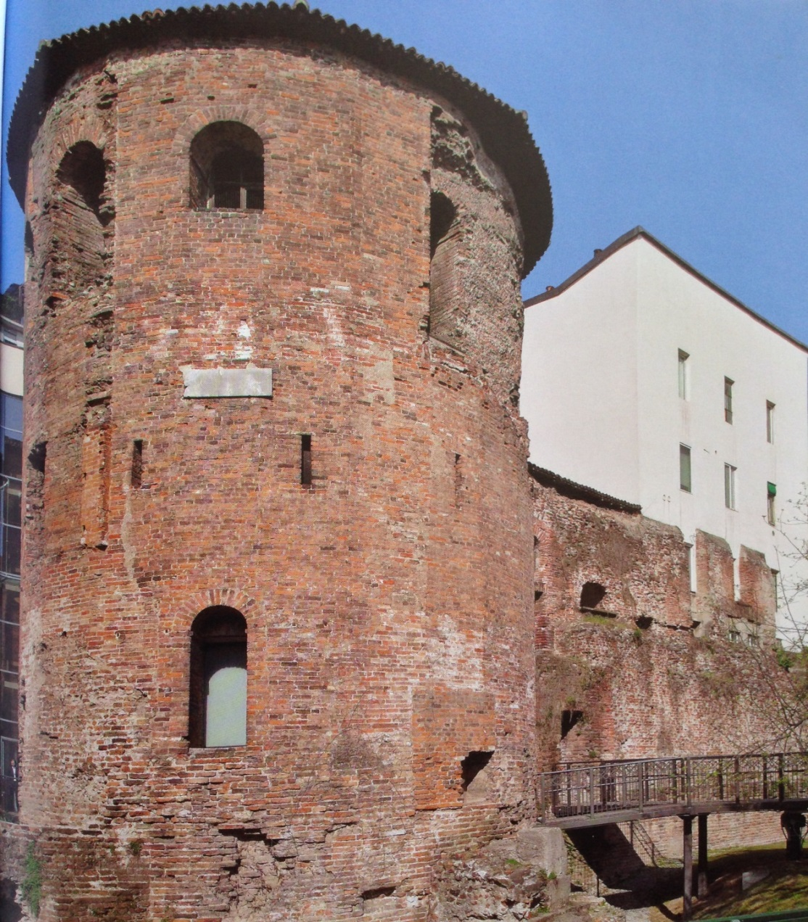
Polygonal tower today

For a 360-degree view of the polygonal tower’s frescos, access this page provided by the Comune Di Milano:

http://www.360visio.com/wp-content/uploads/panoramas/CL2013/MI/Archeo/TorrePoli/output/index.html

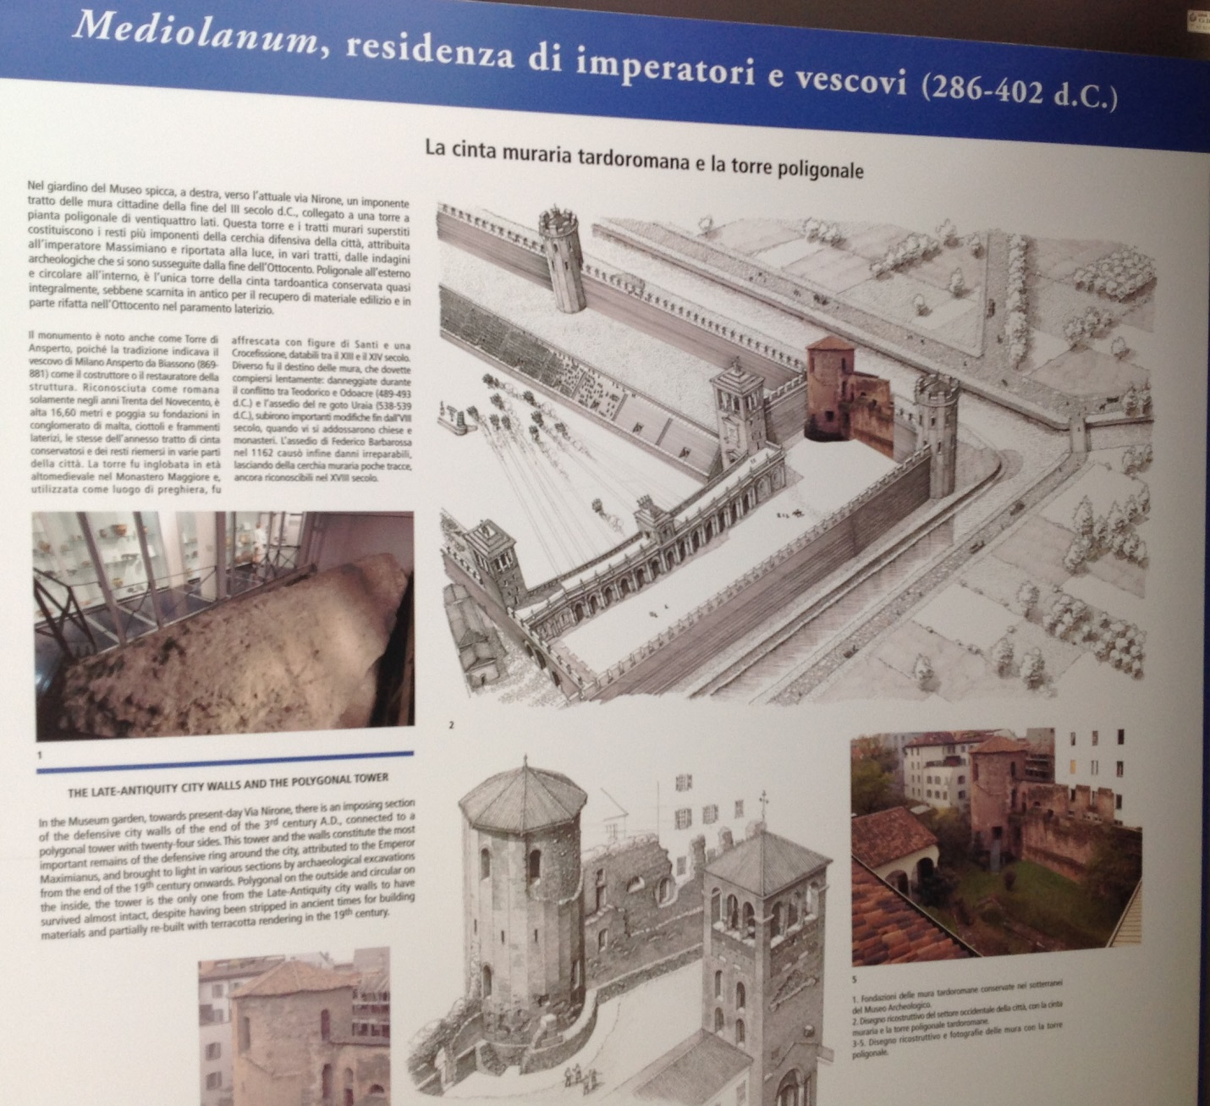
Location of the Polygonal tower in relation to the carceres

After several convent buildings were torn down because they were damaged by the WWII bombing, the area underwent extensive archeological excavations. In the 1960s the new Civico Archeologico Museo of Milano was built next door to the church of San Maurizio. The museum has a four-story building displaying locally collected ancient artifacts and incorporates on its ground remnants of the city walls, the two towers mentioned above and the foundation of a domus, a luxurious private Roman house.

Maximian, who became first Caesar and then Augustus when Diocletian established the tetrarchy, selected Mediolanum (Milan) as his primary residence. As it was customary at the time, Maximian built a circus next to his imperial palace.

It is estimated that the circus was erected around the end of the third century. Humphrey (see Suggested Reading on Home page) designates it as monumental, that is, modelled after Circus Maximus. There is one difference: the curved end did not have a Triumphal Arch that was present in the Circus Maximus.
Lack of the Arch is understandable. The Triumphal Arch is intended to be a gate. The curved end of the circus in Milan doubled as city walls – see image below. An Arch at the curved would have been impractical.

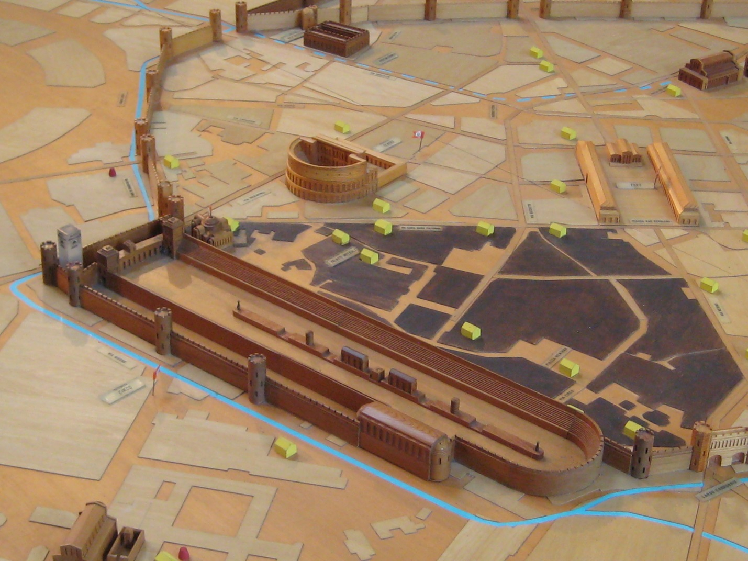 Wooden model of the circus, located in the entrance hall of the archeological museum

The blue surface covers the area of the imperial palace. Notice that the pulvinar (the Emperor throne) is missing from the model. A pulvinar likely existed, but there is no record of it. The excavations in that location are difficult due to the existing city buildings and nothing has been found as of yet. For the same reason the ornaments on the barrier euripus are pure guesswork. The thick blue line outside the city walls represents the creek Nirone. Nirone was the source of water for the euripus. Water flowing on the euripus was an essential component of a circus. Today Nirone runs under city streets.

The square tower is pictured below. The current loggia that tops the tower was built in the medieval times. The tower was originally around 20 meters tall, hence a bit shorter than today.

Its location in relations to the carceres and the circus are shown in the museum plaque inserted below. Note that the monuments on the euripus and the imperial palace are hypothetical reconstructions.

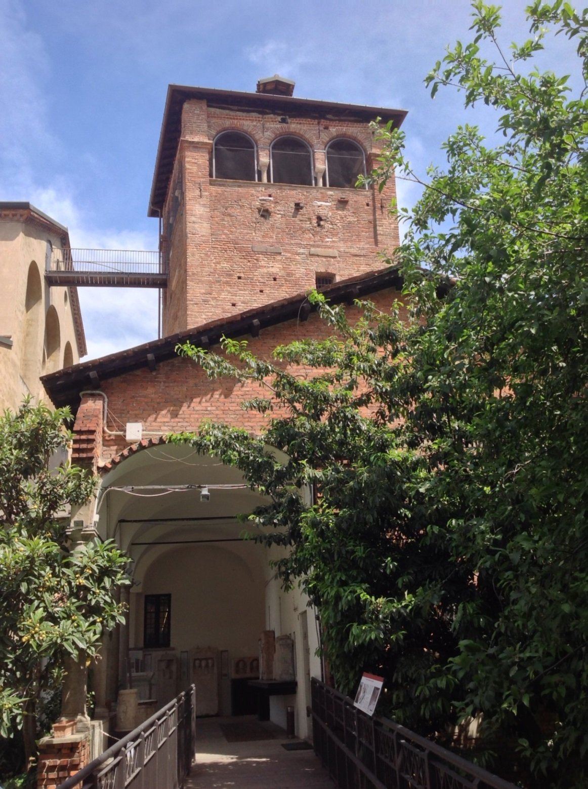
The square tower, as seen from inside the museum

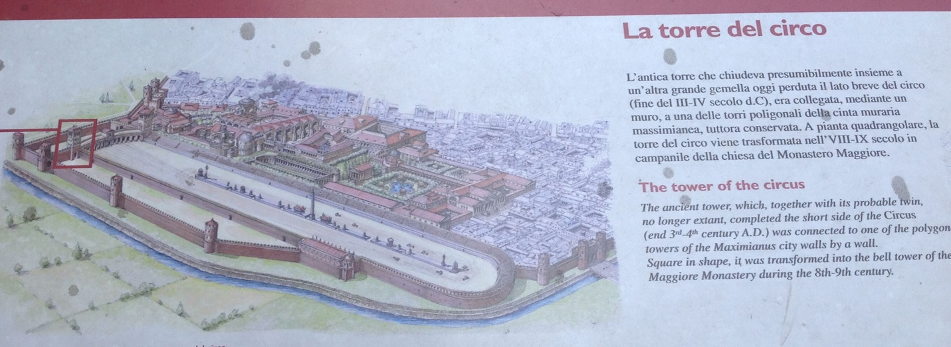
From a plaque of the archeological museum with the square tower highlighted in red

One last item: about a mile from the museum stands the Basilica of Sant’Ambrogio. One of the oldest churches in Milan, the basilica was rebuilt in the Romanesque style in the 11th century. Its campanile (bell tower) is shown in the picture below. The campanile bears a strong resemblance to the square tower. Has that single remaining tower that once flanked the carceres of the circus of Mediolanum inspired the design of bell tower of Romanesque style churches built in the Middle Ages?

